**DAILY ONLINE ACTIVITIES SUMMARY**

|  |  |  |  |  |  |  |  |  |
| --- | --- | --- | --- | --- | --- | --- | --- | --- |
| **Date:** | **15-06-2020** | | | | | **Name:** | **Anix Jugal D’Cunha** | |
| **Sem & Sec** | **8 sem , A sec** | | | | | **USN:** | **4AL16CS013** | |
| **Online Test Summary** | | | | | | | | |
| **Subject** | | **SMS** | | | | | | |
| **Max. Marks** | | **60** | | **Score** | | | **Marks Not Emailed by TechGig** | |
| **Certification Course Summary** | | | | | | | | |
| **Course** | **Learn Java From Scratch** | | | | | | | |
| **Certificate Provider** | | | **Udemy** | | **Duration** | | | 32 min |
| **Coding Challenges** | | | | | | | | |
| **Problem Statement:** Java Program to Reverse a Sentence Using Recursion | | | | | | | | |
| **Status: Competed** | | | | | | | | |
| **Uploaded the report in Github** | | | | | **yes** | | | |
| **If yes Repository name** | | | | | **alvas-education-foundation/dcunhaanixjugal** | | | |
| **Uploaded the report in slack** | | | | | **yes** | | | |

Online Test Details: (Attach the snapshot and briefly write the report for the same)

Marks Not Emailed by TechGig

Certification Course Details: (Attach the snapshot and briefly write the report for the same)

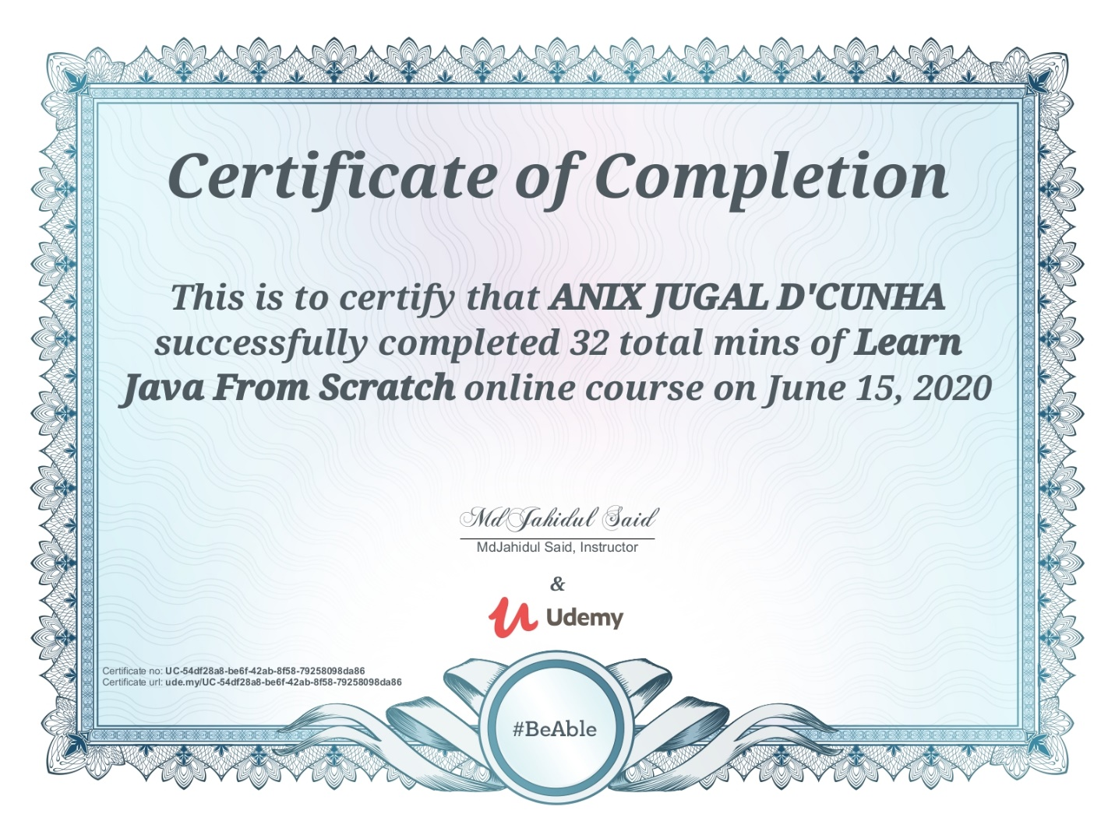

Coding Challenges Details: (Attach the snapshot and briefly write the report for the same)

Program-> Java Program to Reverse a Sentence Using Recursion

|  |
| --- |
|  |
|  |  |
|  |  |
|  |  |
|  | public class Reverse { |
|  |  |
|  | public static void main(String[] args) { |
|  | String sentence = "Go work"; |
|  | String reversed = reverse(sentence); |
|  | System.out.println("The reversed sentence is: " + reversed); |
|  | } |
|  |  |
|  | public static String reverse(String sentence) |
|  | { |
|  | if (sentence.isEmpty()) |
|  | return sentence; |
|  |  |
|  | return reverse(sentence.substring(1)) + sentence.charAt(0); |
|  | } |
|  | } |
|  |  |
|  |  |